**ALETHEIA CHRISTIAN ACADEMY**

**Student Enrollment Packet**

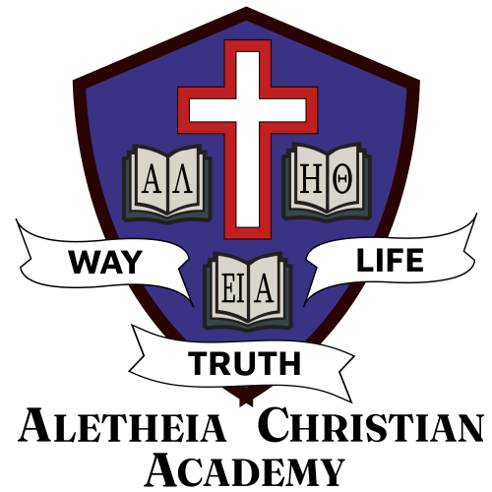

**42457 171st Ave,**

**Holdingford, MN 56340**

**Phone: (320) 746-0005**

**Website: AletheiaChristianAcademy.com**

**ALETHEIA CHRISTIAN ACADEMY**

PO BOX 37 • 42457 171ST AVE

HOLDINGFORD, MN56340

P: 320-746-0005

**APPLICATION FOR ENROLLMENT**

Student’s Name ________________________________________________________________________

First Middle Last

Address ______________________________________________________________________________

Street City) State Zip code

Date of Birth ____/____/_____ Sex _________ Wishes to enroll in grade _________ on _____________

Month/Year

Parent’s Email Address ______________________________________ Primary Phone _______________

School District you presently reside in: _____________________________________________________

Name ISD Number

List Chronologically all schools attended, including preschool and kindergarten. (If any education was homeschooling, please describe courses and give dates. Use supplemental information form if needed.)

Dates Grade Name of School Mailing Address

______________________________________________________________________________________

______________________________________________________________________________________

______________________________________________________________________________________

The child’s scholastic grades have been:

Superior ______ Above Average ______ Average ______ Below Average ______

Has the child ever failed to be promoted to the next grade? _____

Does the child have any health conditions that limit his/her ability to fully participate in a regular school

program, including activities related to classroom curriculum, physical education, recess, etc.? __________

If yes, please describe any limitations:_________________________________________________________

________________________________________________________________________________________

________________________________________________________________________________________

*We desire to educate as many young people as possible. However, we are not equipped to handle students with substantial learning disabilities (IEPs), sever emotional problems, or an uncooperative spirit towards policy and discipline.*

Family’s Church ________________________ Address:___________________________________________

Does your family attend church regularly? _________ Sunday School regularly? __________

**\*\* First-time enrolling families only:**

**Please attach a short Christian testimony from one or both the parents.\*\***

**Use a Supplemental Information Form if desired.**

Comment on the child’s personality traits (outgoing, congenial, responsible, temperamental, shy, fearful,

aggressive, domineering, etc.) ____________________________________________________________

_____________________________________________________________________________________

_____________________________________________________________________________________

Family status: ____Single ____Married ____Separated ____Divorced ____Widowed

____ One or both parents deployed in the military

Father_____________________________________

Name

__________________________________________

Address

__________________________________________

Phone Numbers

__________________________________________

Occupation Employer

Mother____________________________________

Name

__________________________________________

Address

__________________________________________

Phone Numbers

__________________________________________

Occupation Employer

List other children in the family:

Name Age School Attending

_____________________________________________________________________________________

_____________________________________________________________________________________

_____________________________________________________________________________________

Early childhood screening is required prior to applying for kindergarten. What district were you screened

in? __________________________________________

Why do you desire to enroll your child in Aletheia Christian School? ______________________________

_____________________________________________________________________________________

_____________________________________________________________________________________

_____________________________________________________________________________________

If accepted for enrollment, do you consent to your child’s/children’s image being used on printed and online promotional materials? ____ Yes ____ No

We shall endeavor to support and uphold the student handbook and the ideals of the school in every way. We agree to pay all the fees pertaining to the enrollment of our child.

_______________________________________ _______________________________________

Signature of Father Date Signature of Mother Date

*Aletheia Christian School accepts students without regard to race, color, sex, or national or ethnic origin.*

**TUITION RATES AND FEES**

|  |  |
| --- | --- |
|  | **Annual Tuition** |
| **First Child** | $3,900 |
| **Second Child** | $2,900 |
| **Third + Child** | $2,400 |
| **4 YO Pre-K** | $1,800 |

**FEES:**

**Application Fee –** A $100 application fee applies one time per family at initial enrollment only; it does not apply to re-enrollment. Application fees are not refundable.

**Returned Check Fee** - Any check returned to us due to insufficient funds will result in a fee of $35.00. Replacement of the funds must be done via money order or cash.

**Late Fee** - A $10 late fee will be added to late payments. Students will not be permitted to attend school if the late payment is not made by the last day of the month in which the payment is due.

**Payment Plans:**

Three payment plans are offered: 10-pay, 3-pay, and 1-pay. Below are payment due dates. Tuition must be paid in full by May 15.

*Please check one box below to select your payment plan for the upcoming school year.

**€ 10-Pay**

|  |  |  |  |  |  |
| --- | --- | --- | --- | --- | --- |
| **Payment** | **Payment Due** | **Payment** | **Payment Due** | **Payment** | **Payment Due** |
| **1** | August 15 | **5** | December 15 | **9** | April 15 |
| **2** | September 15 | **6** | January 15 | **10** | May 15 |
| **3** | October 15 | **7** | February 15 |  |  |
| **4** | November 15 | **8** | March 15 |  |  |

**€ 3-Pay**

|  |  |  |  |
| --- | --- | --- | --- |
| **Payment** | **Payment Due** | **Payment** | **Payment Due** |
| **1** | August 15 | **3** | February 15 |
| **2** | November 15 |  |  |

**€ 1-Pay**

**Financial aid** is available to assist families with the cost of tuition. To apply for financial aid, see our website: AletheiaChristianAcademy.com.

|  |  |
| --- | --- |
| **Payment** | **Payment Due** |
| **1** | August 15 |

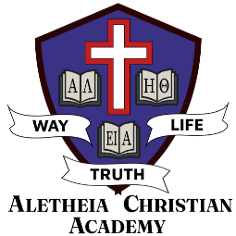

**ALETHEIA CHRISTIAN ACADEMY**

**PARENT/ADMINISTRATION PARTNERSHIP AGREEMENT**

I authorize ACA to instruct my child both spiritually and academically with biblical truth as the foundation, Christ as the model, and Christlikeness the goal.

I recognize ACA as an extension of my home and my parental responsibilities.

1. I agree with the philosophy, purpose, and goals of ACA.
2. I agree with the policies in the Parent/Student Handbook of ACA and will support the teachers and administrators in their modeling, teaching, and implementing of these policies. In case of minor differences, I am content to defer to the school administration.
3. I will, in my home, diligently work with and consistently support the administration, faculty, and staff of ACA in the training and discipline of my child.
4. If I have questions, concerns, or points of difference with the administration, faculty, or staff of ACA, I will speak directly and exclusively to those involved, beginning with the teacher, and I will do so in a spirit of humility and cooperation, with the goal of settling all differences biblically and selflessly. If I cannot settle such differences in a Christ-like way to the satisfaction of all parties involved, I will voluntarily remove my child from ACA and transfer them to a school whose philosophy and standards are more in keeping with the philosophy and standards of my home. (Matthew 18).
5. I view my child's enrollment at ACA as a privilege and not a right, and I will endeavor as a parent to support consistently and pray diligently for the personnel and ministry of ACA that, together, we might train young men and women who are equipped to model truth and excel mentally, socially, and spiritually in a world of great spiritual need.

**The Administration, Faculty and Staff of ACA Agree To:**

1. Strive to give students of ACA the best possible academic instruction in the context of a biblical

world view, personal faith in Christ, and deep Christian love.

1. Apply the standards of ACA to all students as stated in the student handbook lovingly, equitably, firmly, and consistently in order to create an environment that is well-ordered and conducive to learning, to assist students in the process of growing in Christ, and to aid parents in the raising of their children for God's glory.
2. Contact parents directly when their child evidences a pattern of unconcern, disrespect, or disobedience toward the scholastics, standards, or authorities of ACA or toward fellow students at ACA.
3. Remember that ACA is an extension of the homes we serve and to strive to keep communication open between home and school as well as school to home,

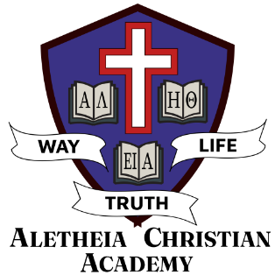

**Aletheia Christian Academy**

42547 171st Ave, Holdingford, MN 56340

320-746-0005

**Statement of Faith and Parent/Student Handbook Acceptance and Acknowledgment**

I **have received a copy of the Aletheia Christian School's Statement of Faith**. I understand it is my responsibility to become familiar with and adhere to the information contained therein. I fully support the Statement of Faith and the biblical positions taken by this ministry on the issues of doctrine and agree with the lifestyle positions contained therein, both at and away from school/church.

I have **also received a copy of the Parent/Student Handbook**. I understand that it is my responsibility to read and comply with the requirements contained therein and help my student(s) do the same, both at and away from school/church. I agree that my student and I must abide by the standard of conduct contained therein and understand that if, at any time during or away from Aletheia Christian School, my student or I violate any provisions of the Standard of Conduct or engage in any of the behaviors listed in the Discipline: section of the Parent/Student Handbook, that I am subject to the discipline listed therein, up to and including my student’s suspension or expulsion from school..

**Please sign below, indicating agreement** **with the above statements**.

_________________________________________________ ________________________________________________  
Print Parent Name  Parents Signature Date

_________________________________________________ ________________________________________________  
Print Parent Name  Parents Signature Date

_________________________________________________ ________________________________________________  
Print Administrator Name  Administrator Signature Date